Yunlu Li

STAT 5170

Homework 9

1. (a)

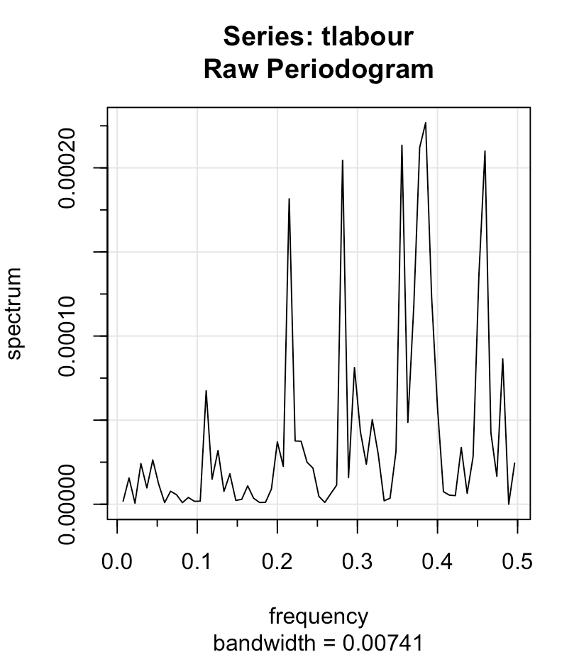

(b) The raw periodgram does not estimate the power spectrum well, which is caused by high variability in estimates. We apply smoothing because we want to reduce the variance.

(c) As shown below, I noticed 6 spikes in total.

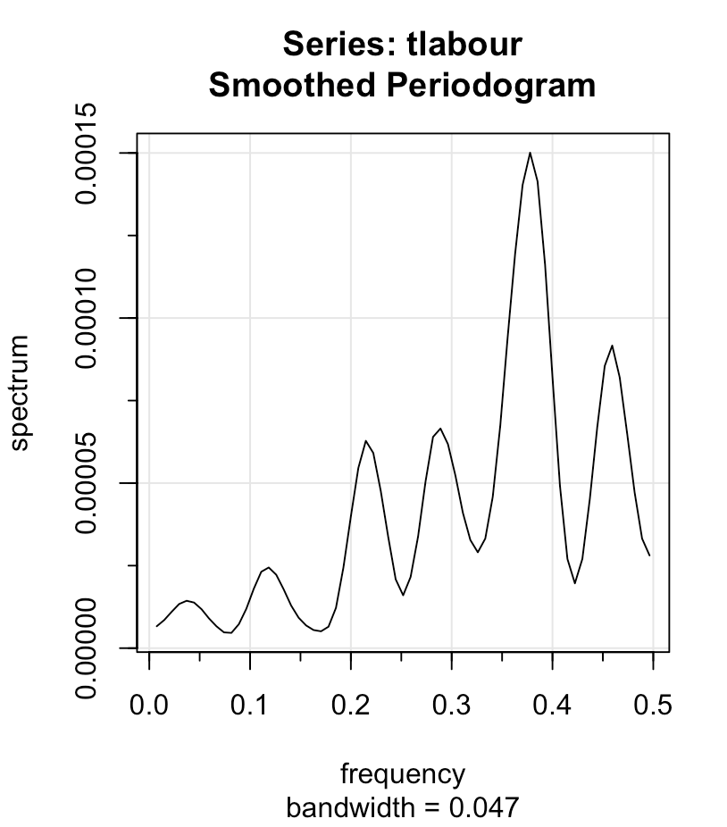

(d) The length of *tlabour* is 133 and the next composite number is 135.The which.max(tlabour.smooth$spec) returns 51, so dominant frequency is $\frac{51}{135}$.

(e) tlabour.smooth$spec[51] gives 0.0001500919

(f) The 95% CI for highest estimated spectral density is (7.771462e-05, 4.026609e-04). The estimated spectral density at next highest peak is 9.167153e-05, which is included in our CI. Thus, the spectral density at w\* is not significantly higher than that at next highest peak.

2. (a) Daniell kernel, m=4 and repeat 5 times

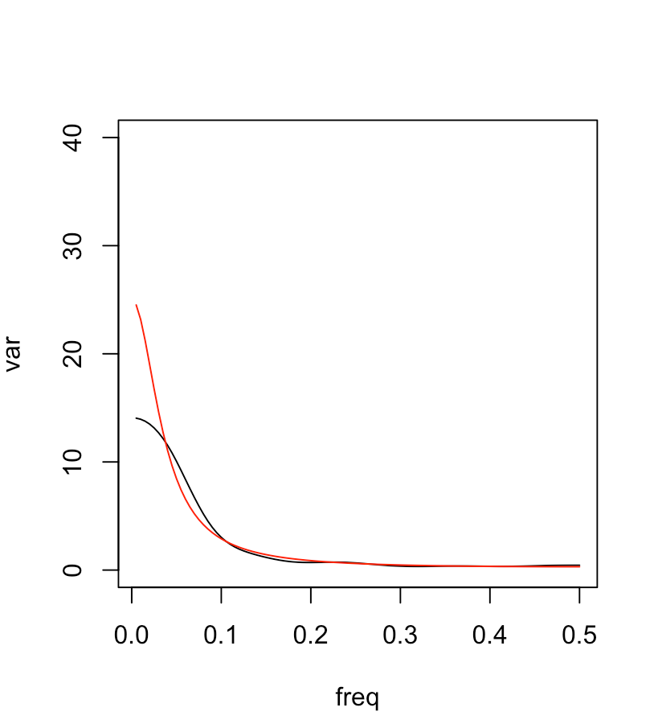

Modified Daniell kernel, m=5 and repeat 5 time

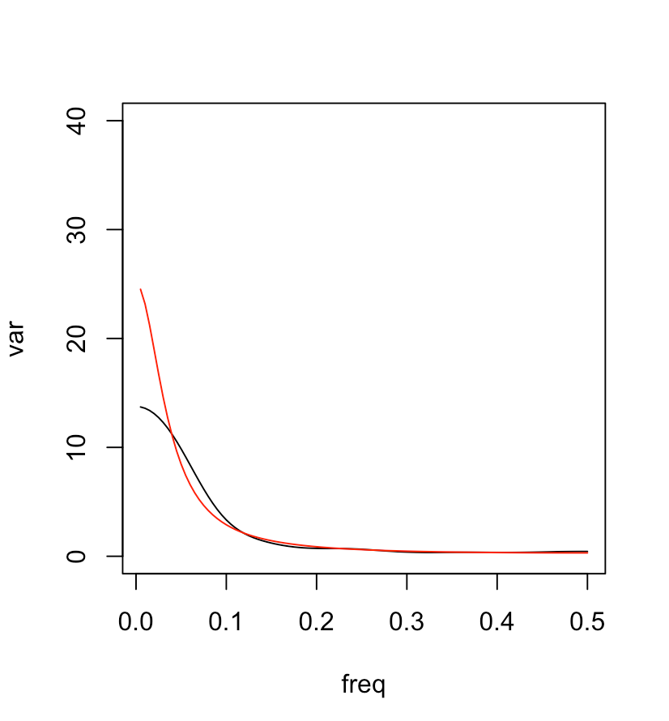

Modified Daniell kernel, m=7 and repeat 4 time

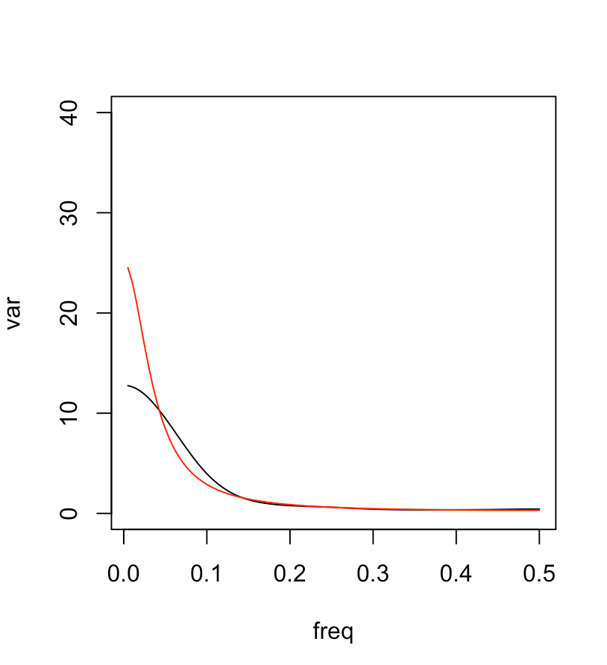

(b) The true spectral density of frequency<0.05 is hard to estimate. Even after smoothing, difference between true and estimated spectral density at lower frequency is still large.

(c) The unsmoothed periodgram with 400 data has much more spikes than that with 200 data.

The smoothed periodgram comes from modified Daniell kernel with m=7 and repeating 10 times.

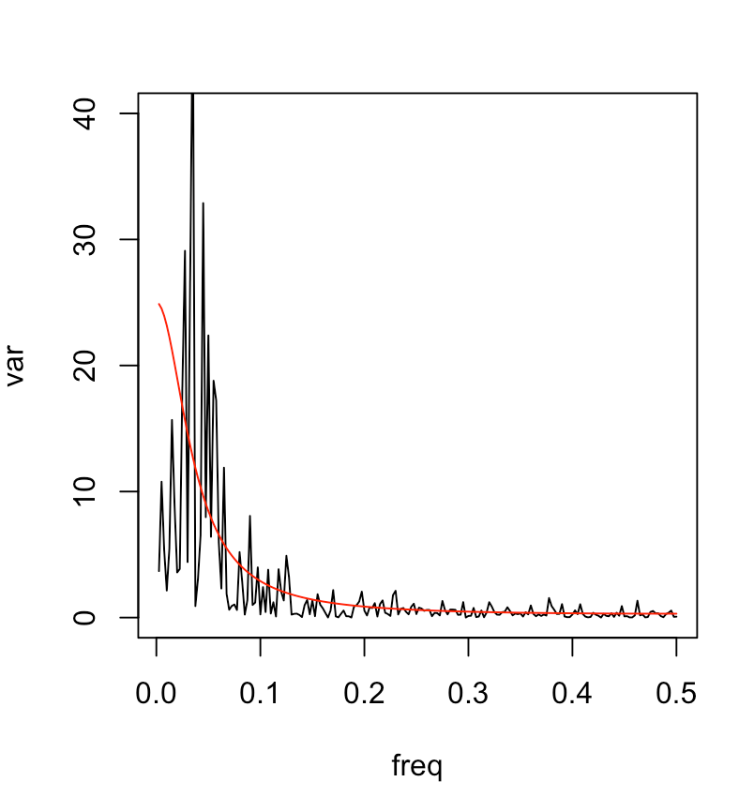 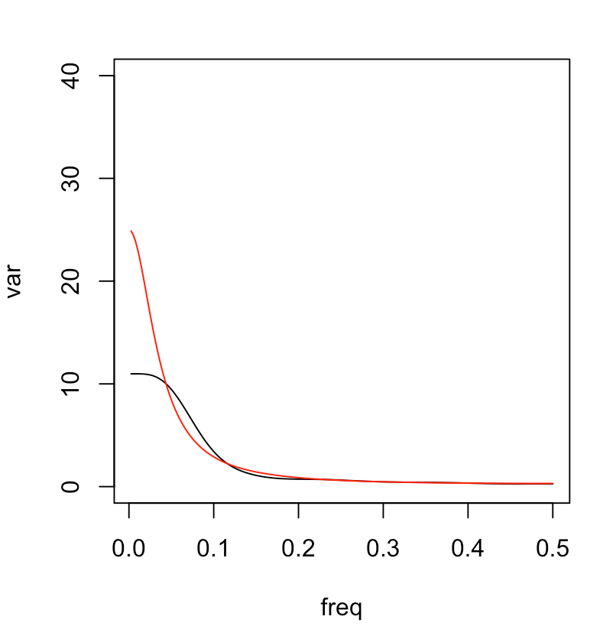

3. (a) for

(b) . Thus, $f_{y}\left(w\right)=\frac{4}{9}{\left[\cos\left(2πw\right)-1\right]}^{2}σ_{w}^{2}$

(c) Frequency>0.1 will be retained and frequency<0.1 will be dampened.

